Asia-China-Coin Collection 4

SHAPE \\* MERGEFORMAT 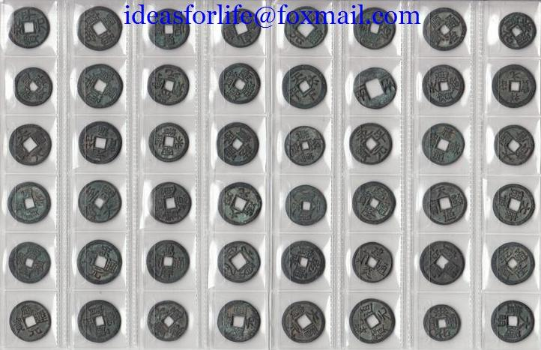

SHAPE \\* MERGEFORMAT 